Ex9-Create a simple cloud software application for Hospital information system for SIMATS Hospital using any Cloud Service Provider to demonstrate SaaS with fields of patient name, age, address, phone, email, Attender name, attender phone, doctor name, diseases, etc.

PROCEDURE:

Step 1: Create a new application as healthcare

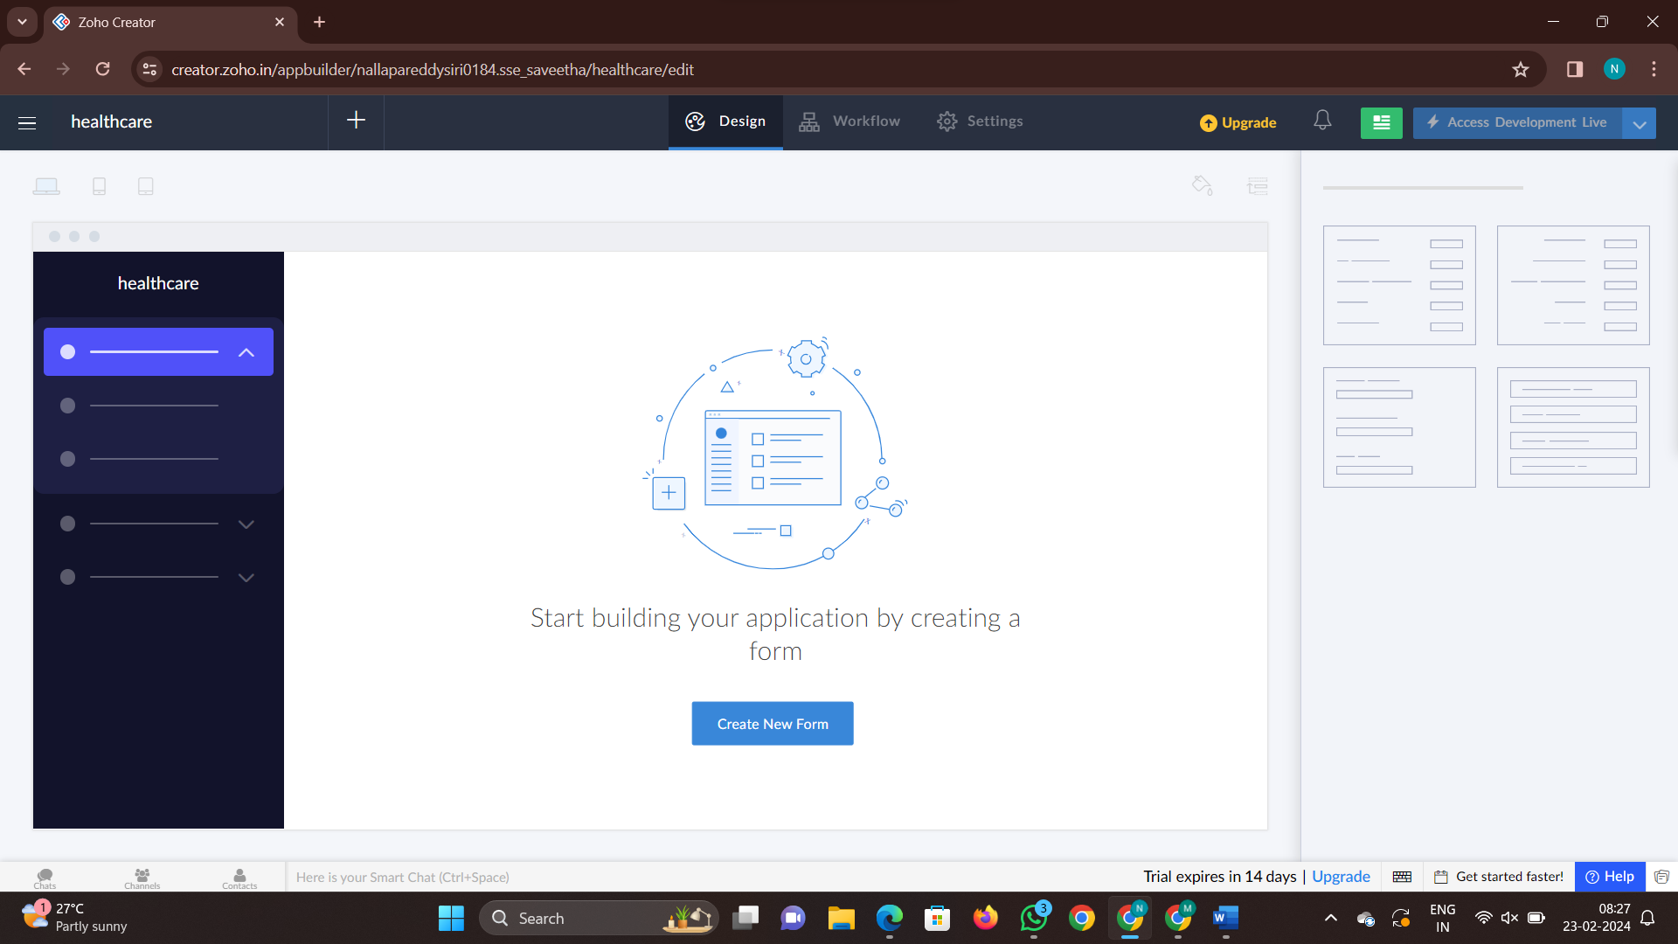

Step 2: Add a new form to fill the details

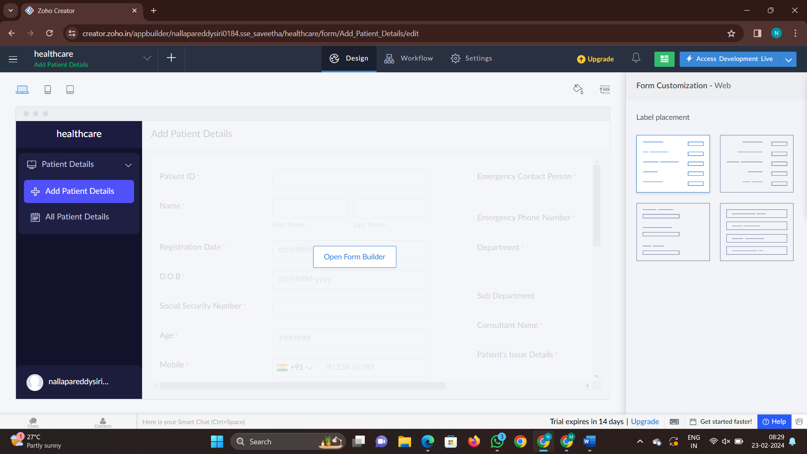

Step 3: Add another form as history

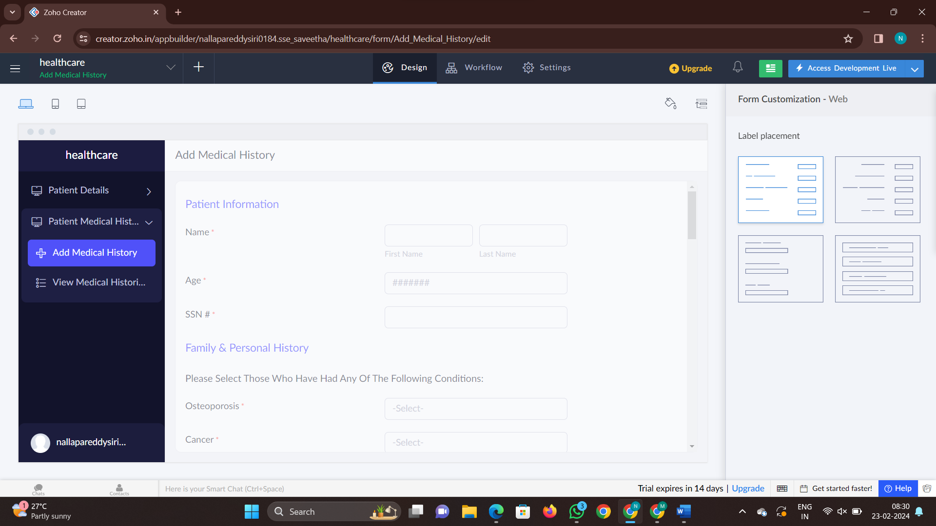

Step 4: Add another form as patient analysis

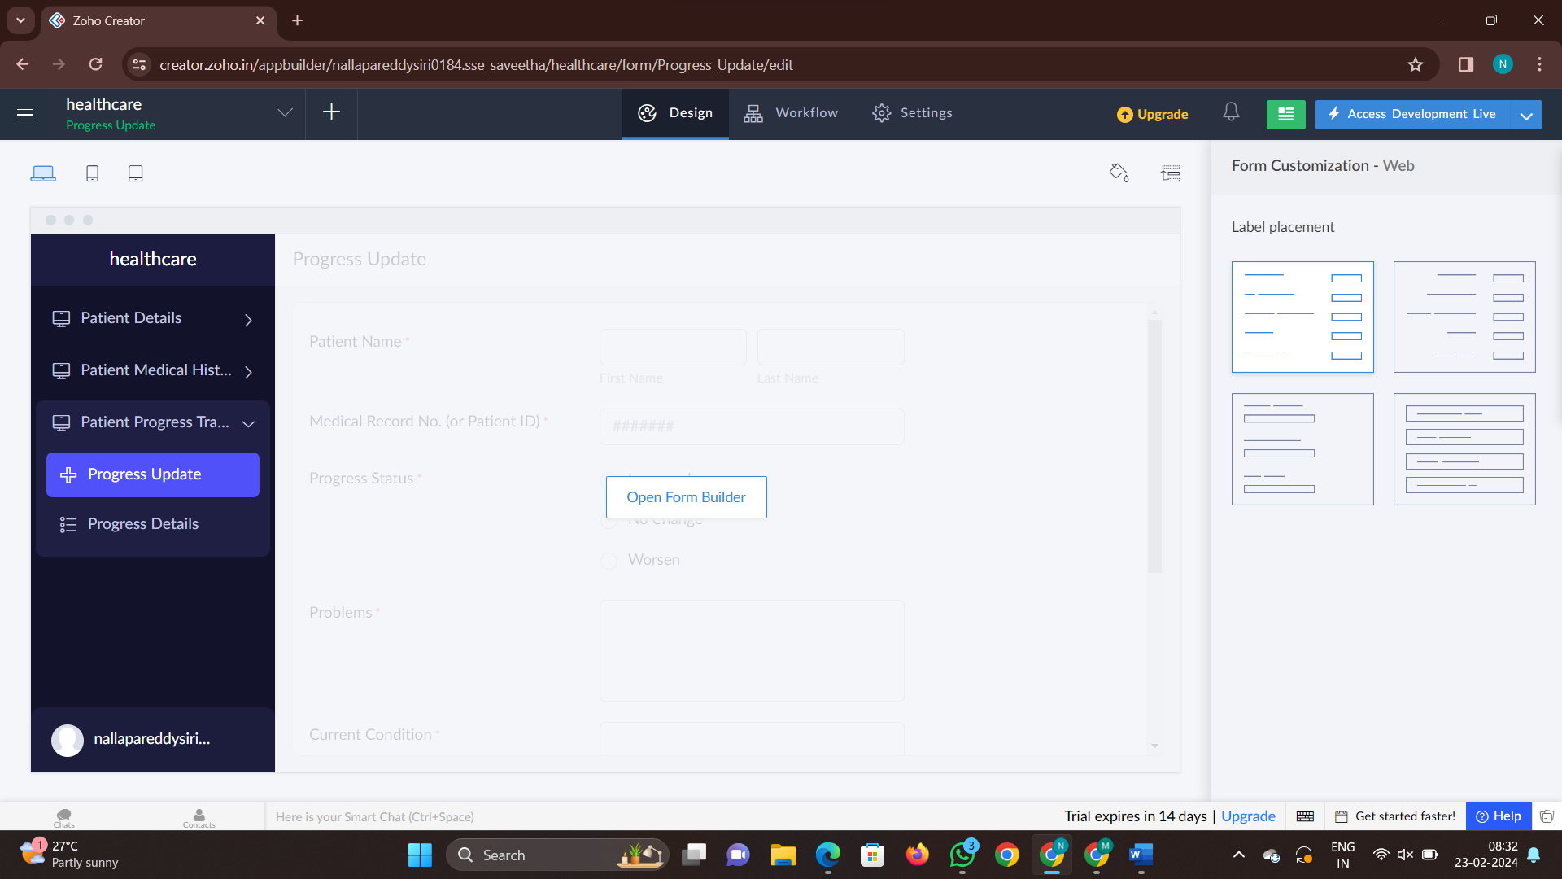

Step 5:now click on access development live anf fill the details

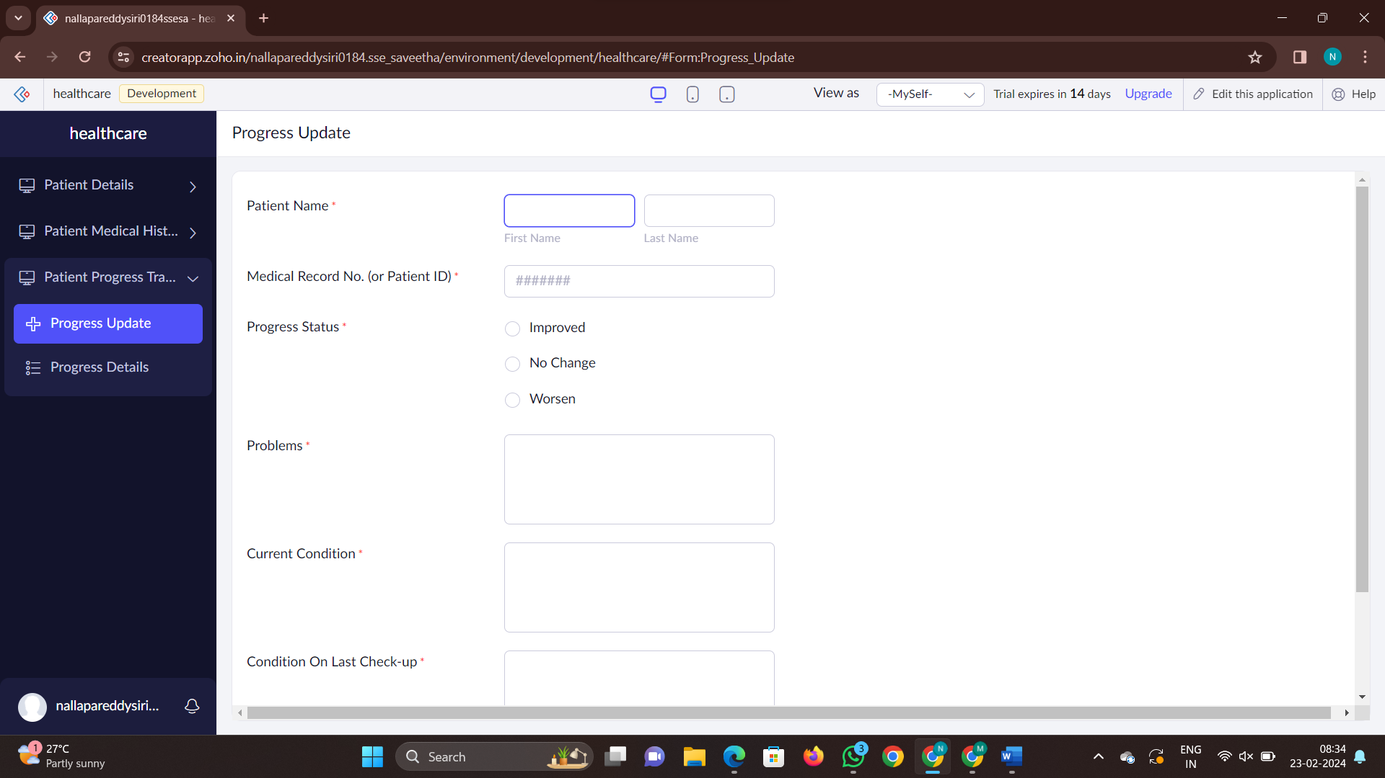

Step 7: check the report of the given forms

